FOOD WASTE REDUCTION APP
@CREATIVITY THINK (9483175986/7019689991)

ABSTRACT:
Food Waste Reduction App is a web platform aimed at connecting surplus food providers, such as restaurants and individuals, with recipients including NGOs and social groups. Users can browse food offers, request pickups, and monitor their impact via interactive dashboards. Administrators manage campaigns, moderate posts, and analyze impact statistics. The backend leverages Django and Django Rest Framework for secure data handling, authentication, and business logic, while the frontend uses React, Redux, and Recharts to deliver a responsive and interactive interface. This platform facilitates efficient food redistribution and real-time impact tracking for both users and administrators..

INTRODUCTION OF THE PROJECT:
Food wastage is a significant global issue, often leading to environmental and social challenges. The Food Waste Reduction App addresses this by enabling providers to post surplus food and connect with recipients who can make use of it. Users can request pickups and view dashboards reflecting the social impact of their contributions. Administrators oversee campaigns, moderate posts, and analyze aggregated data. Using Django and Django Rest Framework for the backend, combined with React, Redux, and Recharts on the frontend, ensures secure, responsive, and insightful food redistribution management..

PROJECT OBJECTIVES:

• Enable posting and sharing of excess food by users
• Allow recipients to search for available food offers
• Facilitate pickup requests and tracking
• Provide dashboards to visualize impact and analytics
• Allow administrators to manage campaigns and moderate posts
• Offer reporting tools to evaluate food waste reduction
• Promote social and environmental awareness

PROBLEM OF THE STATEMENT:
Food waste is a pressing concern that impacts both the environment and communities in need. Restaurants, households, and organizations often generate excess food that goes unused. Traditional distribution methods are inefficient and lack visibility into impact. The Food Waste Reduction App solves this problem by connecting surplus food providers with recipients, enabling pickup requests, and tracking the redistribution impact through dashboards. Administrators manage campaigns, moderate content, and generate reports to ensure effective food utilization and waste reduction..

MOTIVATION OF THE PROJECT:
• Reduce food wastage in communities and organizations
• Provide a platform for efficient redistribution of surplus food
• Enable users to monitor their positive social impact
• Allow administrators to manage campaigns and track metrics
• Support environmental sustainability and social responsibility

BLOCK DAIGRAM OF PROJECT:

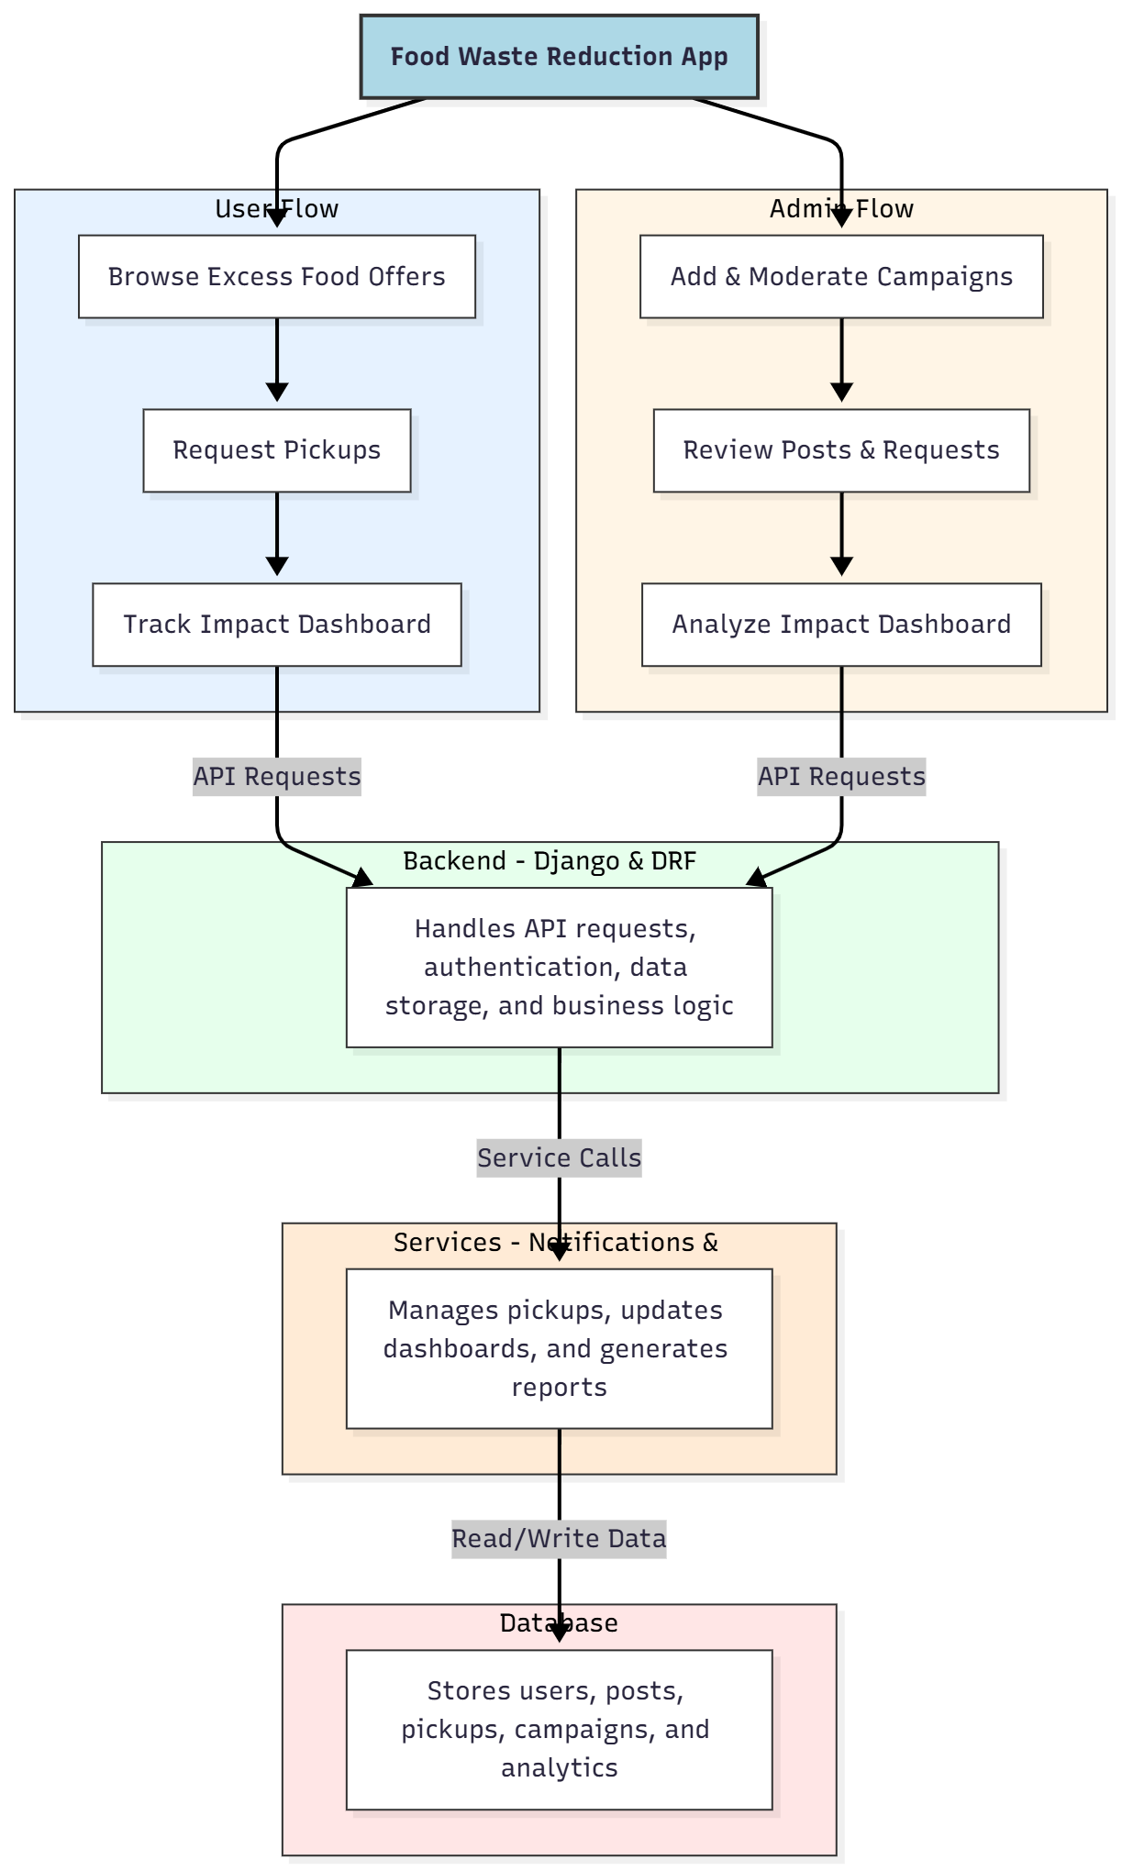

WORKING OF THE PROJECT:
Users browse posts of excess food and submit pickup requests. They can track their contributions and view the impact through interactive dashboards. The backend handles API requests, authentication, business logic, and data storage. Services process pickup scheduling, notifications, and analytics updates. Administrators add and moderate campaigns, review posts and requests, and generate dashboard analytics. The system ensures efficient redistribution of surplus food while providing insight into the social and environmental impact of user activities..

SOFTWARE REQUIREMENT:
- Backend:
  - Python 3.x
  - Django
  - Django REST Framework
  - SQLite/PostgreSQL
- Frontend:
  - Node.js and npm
  - React.js
  - Axios
- Development Tools:
  - Visual Studio Code
  - Postman (for testing APIs)
  - Git/GitHub (for version control)
- Server/Deployment (Optional):
  - Gunicorn, Nginx, or Heroku/AWS for hosting

ADVANTAGES OF THE PROJECT:

• Reduces food wastage effectively
• Connects surplus food providers with recipients
• Tracks contributions through dashboards
• Provides administrative campaign and moderation controls
• Offers analytical insights for impact evaluation
• Supports environmental and social responsibility
• Web-based and accessible from multiple devices
• Facilitates efficient resource redistribution

APPLICATIONS OF THE PROJECT:
• NGOs and charities for food redistribution
• Restaurants and cafes for surplus management
• Social groups and community kitchens
• Schools and colleges promoting sustainability initiatives
• Event organizers managing leftover food
• Municipal food waste programs
• Real-time tracking of food distribution
• Dashboard analytics for environmental impact reporting

REFERENCES:

- Django REST Framework Documentation — Django Software Foundation. Django Documentation. Available: https://docs.djangoproject.com/
- Django REST Framework. DRF Documentation. Available: https://www.django-rest-framework.org/
- React. React Official Documentation. Available: https://reactjs.org/docs/getting-started.html
- Redux. Redux Documentation. Available: https://redux.js.org/introduction/getting-started
- PostgreSQL Global Development Group. PostgreSQL Documentation. Available: https://www.postgresql.org/docs/
- MySQL. MySQL Reference Manual. Available: https://dev.mysql.com/doc/
- Git. Git Documentation. Available: https://git-scm.com/doc
- Node.js. Node.js Documentation. Available: https://nodejs.org/en/docs/
- Axios. Axios Documentation. Available: https://axios-http.com/docs/intro
- Socket.io Documentation – https://socket.io/docs/

